Optic Nerve Head Perfusion Changes Before and After Intravitreal Anti Vascular Endothelial Growth Factor Injections Using Optical Coherence Tomography-based Microangiography

Abstract
Background: Normal vision relies on the choroid, retina, and optic nerve head (ONH), with impaired perfusion contributing to ocular diseases such as glaucoma. This study evaluated ONH perfusion changes after intravitreal anti-VEGF injections using OCTA.
Methods: In this prospective observational study, 25 patients received intravitreal anti-VEGF injections (IVI). Postoperative care included topical moxifloxacin and anti-glaucoma medications if intraocular pressure (IOP) increased. The primary outcome was ONH perfusion and vessel density changes on OCTA before and after IVI. Secondary outcomes included retinal nerve fiber layer (RNFL) thickness and IOP alterations measured 30 minutes before and 60 minutes after injection.
Results: Inside-disc vessel density significantly decreased in injected eyes (P<0.001), while fellow eyes showed no significant change (P=0.572). Other vessel density parameters, including whole, peripapillary, and sectoral densities, were unchanged in both groups (P>0.05). Peripapillary (P=0.002) and superior hemispheric (P<0.001) RNFL thickness significantly decreased in injected eyes, whereas inferior hemispheric RNFL showed a nonsignificant reduction (P=0.067). Fellow eyes exhibited no significant RNFL changes (P>0.05).
Conclusions: A single intravitreal anti-VEGF injection causes a modest, transient IOP rise and short-term reduction in intradisc vessel density, while peripapillary perfusion remains largely unaffected.
Keywords: Angiogenesis, VEGF, Retinal ischemia, Ocular hemodynamics, Neuroprotection

Introduction:
Retina, choroid, and optic nerve head (ONH) perfusion is important for the preservation of normal vision. Various ocular illnesses, like glaucoma, may be exacerbated and advanced by a reduction in perfusion ^{[1]}.
The posterior ciliary and central retinal arteries vascularize the ONH. The radial peripapillary capillaries (RPC) are the most prevalent capillaries in the principal capillary bed in the interior portion of the nerve fibre layer (NFL) surrounding the ONH ^{[2]}.
Retinal vein occlusion (RVO), diabetic retinopathy (DR), and age-related macular degeneration (ARMD) are amongst the most prevalent reasons for impaired vision and blindness globally. In these conditions, overexpression of vascular endothelial growth factor (VEGF) has been recognized as a significant pathological action ^{[3]}.
Consequently, the treatment of specific retinal pathologies characterized by macular edema has been transformed by Anti-VEGF. The efficacy of anti-VEGF in reversing retinal edema and enhancing vision has been demonstrated in landmark trials ^{[4-6]}. Despite the favourable safety profile of anti-VEGF, adverse events, like ocular haemorrhage, retinal detachment, endophthalmitis, and an increase in intraocular pressure (IOP), are associated with each injection
^{[7]}.
Generally well-tolerated, transient IOP elevations are a frequent occurrence following intravitreal anti-VEGF injections in the short term ^{[8, 9]}.
Nevertheless, sustained ocular hypertension (OHT) is a more severe complication of frequent doses and has been observed in cases who had long-term treatment ^{[10-12]}.
Optical coherence tomography angiography (OCTA) is a paradigm shift in assessing retinal and ONH microcirculation. It offers a non-invasive alternative to fluorescein angiography, enabling detailed visualization and quantitative analysis of vessel density in the retina, ONH, and peripapillary region ^{[13, 14]}.
OCTA is a noninvasive technique that determines red blood cells dynamic motion in a circulating blood vessel to visualise the ONH and peri-papillary retinal vasculature ^{[15]}.
We aimed to assess the changes in ONH perfusion following Anti-VEGF injections using OCTA.

Patients and Methods:
This prospective observational trial included 25 cases undergoing IVI of anti-VEGF agents. The study was preformed following approval from the Ethical Committee Benha University Hospitals This study was conducted at Benha University Hospital from 20 July 2023 to 20 July 2024 (MS 20-7-2024). An informed written consent was taken from the patient.
Inclusion criteria included patients of both genders, age range: 20–70 years, scheduled for anti-VEGF IVI for macular edema that is a result of DR, RVO, or other vascular causes, patients with active choroidal neovascular membranes (CNVM) undergoing anti-VEGF therapy and both phakic and pseudophakic eyes. Exclusion criteria included media opacity interfering with OCTA and resulting in poor-quality scans, previous cataract surgery within the 6 months preceding the study, previous ocular surgeries other than cataract surgery, diagnosis of any type of glaucoma, presence of active ocular infection or ocular surface disease and high myopia.
All cases were subjected to detailed history taking, systemic evaluation, ocular investigation involved uncorrected visual acuity (UCVA) and best-corrected visual acuity (BCVA) via Landolt’s chart, pupillary reactions and color vision testing, anterior segment assessment by slit-lamp biomicroscopy, Nidek SL-450 NIDEK CO, LTD.,Japan, IOP was measured 30 minutes before and 60 minutes after IVI using air-puff tonometry (TOPCON CT-80), three IOP readings were obtained per eye at each time point, and the mean value was calculated, slit-lamp biomicroscopy utilising a +90D lens and/or indirect ophthalmoscopy utilising a +20D lens were employed to examine the fundus.
OCTA and ONH perfusion were performed by the Optovue AngioVue (Optovue Inc., Fremont, CA, USA) with pupils dilated using 1% cyclopentolate, 30 minutes before and 1 hour after IVI. Scans (HD 3D Angio Disc protocol) included 400 A-scans per B-scan, 640 pixels per A-scan, and 400 B-scans per volume, each repeated ≥2 times, with averaged output. Field of view was 4.5 × 4.5 mm and 6 × 6 mm. Optic disc margins were verified in the SLO view, aligned with Bruch’s membrane opening, and corrected manually if needed, followed by automatic recalculation of disc center and peripapillary metrics. Vessel density analysis included small and large vessels based on Garway-Heath sectors, with OCTA images, density maps, en face structural images, and charts reported. RNFL thickness was measured within 2–4 mm Garway-Heath zones. Peripapillary vessel density (VD) was recognized as VD within a 750-µm annulus from the disc edge ^{[16]}.
Anti-VEGF injections were administered under topical anaesthesia with proparacaine hydrochloride 0.5%. The patient received a topical solution of 5% povidone-iodine, and an eyelid speculum was affixed prior to inoculation. In phakic eyes, an intravitreal injection was administered in the inferotemporal quadrant using a 30-gauge cannula, which was positioned 4 mm posterior to the limbus and 3.5 mm posterior to the limbus in pseudophakic eyes. The anti-VEGF agent was injected at a volume of 0.03 to 0.05 mL. The patient was seated upright and an antiseptic eyewash was administered to the eye immediately after the injection. No paracentesis was done.
Postoperative care included topical moxifloxacin eye drops administered every 4 hours, with topical anti-glaucoma medications prescribed if an elevation in IOP was exhibited.
The primary outcome included the change ONH perfusion and vessel density, as assessed by OCTA, prior to and following intravitreal anti-VEGF injection. The secondary outcomes included alterations in RNFL thickness on OCTA and alterations in IOP at 30 minutes before injection and 60 minutes post-injection.
Approval code : MS 20-7-2024
Statistical analysis

Statistical analysis was performed using IBM SPSS Statistics for Windows, Version 29.0 (IBM Corp., Armonk, NY, USA). Categorical variables were expressed as frequency and percentage, and continuous variables as mean ± SD or median (IQR). Normality was evaluated with the Shapiro–Wilk test. Between-group comparisons used the independent t-test or Mann–Whitney U test, while within-group (pre–post) comparisons used the paired t-test or Wilcoxon signed-rank test. Pearson correlation analyzed relationships between baseline hemodynamic/ocular parameters (MAP, IOP, MOPP, and IOP rise) and changes in OCTA vessel density. A two-tailed p-value <0.05 was regarded statistically significant.

Results:
Table 1 presents baseline and clinical data of the studied cases
Table 1: Baseline and clinical data of the studied patients
 | N= 25
Sex
Male | 11 (44.0%)
Female | 14 (56.0%)
Age (years) | 55.2 ± 8.7
Comorbidities
DM | 19 (76.0%)
HTN | 17 (68.0%)
Cardiac disease | 3 (12.0%)
HCV | 2 (8.0%)
Hyperlipidemia | 1(4.0%)
Cushing disease | 1(4.0%)
Mean BP (mmHg) | 97.8 ± 7.1
Diagnosis
DME | 18 (72.0%)
BRVO | 5 (20.0%)
CNV | 2 (8.0%)
 | N= 50
Injected (study) eye | 25 (50.0%)
Uninjected (fellow) eye | 25 (50.0%)
Eye Side (R/L)
RE | 25 (50.0%)
LE | 25 (50.0%)
Pupil
RRR | 48 (96.0%)
Sluggish | 2 (4.0%)
Color Vision
Full | 50 (100.0%)
Data expressed as frequency (percentage) or mean ± standard deviation. LE: Left Eye, RE: Right Eye, RRR: Round Regular and Reactive, BRVO: Branch Retinal Vein Occlusion, BP: Blood Pressure, CNV: Choroidal Neovascularization, DM: Diabetes Mellitus, DME: Diabetic Macular Edema, HCV: Hepatitis C Virus, HTN: Hypertension.
BCVA was significantly decreased in the injected eyes versus the fellow eyes (P=0.001). No significant difference in pre-injection IOP (P=0.930) or post-injection IOP (P=0.391) was found between both eyes. However, a significant rise in IOP after injection was observed within the injected eyes (P<0.001), while the variation was not significant in the fellow eyes (P=0.114). Table 2
Table 2: Comparison of BCVA and IOP among injected (study) and un-injected (fellow) eyes (N=50).
Variable | Injected (study) eye (n=25) | Un-injected (fellow) eye (n=25) | P-value
BCVA | 0.17 ± 0.10 | 0.36 ± 0.28 | 0.001 ª
Pre-injection IOP (mmHg) | 16 ± 4 | 16 ± 3 | 0.930
Post-injection IOP (mmHg) | 18.6 ± 4.9 | 17.2 ± 2.5 | 0.391ª
P-value (pre vs. post) | <0.001¥ | 0.114¥
Data were expressed as mean ± standard deviation. BCVA: Best-Corrected Visual Acuity, IOP: Intraocular Pressure. (ᵃ) independent t test or Mann–Whitney, (¥) Wilcoxon signed-rank test. P-values < 0.05 indicate significance.
There were no significant differences between the two eyes in the following areas prior to the anti-VEGF injection: whole, inside disc, peripapillary, superior-hemi, inferior-hemi, nasal-superior, nasal-inferior, inferior-nasal, inferior-temporal, temporal-inferior, temporal-superior, supero-temporal, and superior-nasal (0.672, 0.806, 0.554, 0.760, 0.499, 0.613, 0.207, 0.446, 0.781, 0.794, 0.860, 0.348, and 0.415, respectively). Following injection, inside disc vessel density was significantly decreased in the injected eyes versus the uninjected ones (P<0.001). Conversely, no significant differences were present in whole, peripapillary, or sectoral vessel density parameters (all P>0.05). (Figure2) (Figure3).
Comparing the pre- and post–anti-VEGF injection vessel density parameters in both injected and fellow eyes. Following the injection, the inside disc vessel density revealed a significant decrease in the injected eyes (P<0.001), while no significant changes were demonstrated in the un-injected eyes (P=0.572). Other vessel density parameters, including whole, peripapillary, and sectoral densities, did not differ significantly pre- and post-injection in either group (all P > 0.05). Table 3
Table 3: Comparison of before and after anti-VEGF injection vessel density in the injected (study) and uninjected (fellow) eyes (N=50).
Variable | Injected (study) eye (n=25) |  |  | Uninjected (fellow) eye (n=25)
Variable | Before anti-VEGF injection | After anti-VEGF injection | P-value | Before anti-VEGF injection | After anti-VEGF injection | P-value
Whole Density (%) | 47.6 ± 3.3 | 45.8 ± 4.5 | 0.053 ^{t} | 47.1 ± 3.9 | 47.5 ± 3.6 | 0.521 ^{t}
Inside Disc (%) | 46.8 ± 5.7 | 39.1 ± 7.6 | <0.001¥ | 47.1 ± 5.5 | 46.6 ± 5.8 | 0.572¥
Peripapillary (%) | 50.3 ± 3.7 | 49.1 ± 5.3 | 0.288¥ | 49.5 ± 5.0 | 49.6 ± 4.2 | >0.999¥
Superior-hemi (%) | 50.2 ± 3.1 | 49.2 ± 5.0 | 0.282 ^{t} | 49.9 ± 5.0 | 49.9 ± 4.6 | 0.966 ^{t}
Inferior-hemi (%) | 50.2 ± 4.8 | 48.9 ± 6.3 | 0.214 ^{t} | 49.2 ± 5.6 | 49.1 ± 4.6 | 0.947 ^{t}
Nasal-superior (%) | 47.5 ± 5.7 | 47.2 ± 6.7 | 0.782 ^{t} | 46.7 ± 5.4 | 47.1 ± 5.4 | 0.717 ^{t}
Nasal-inferior (%) | 46.1 ± 6.5 | 45.4 ± 7.8 | 0.726¥ | 44.0 ± 6.5 | 45.4 ± 6.2 | 0.128¥
Inferior -nasal (%) | 50.1 ± 5.9 | 49.2 ± 7.3 | 0.413 ^{t} | 48.8 ± 6.2 | 48.3 ± 5.9 | 0.488 ^{t}
Inferior-temporal (%) | 54.8 ± 6.6 | 53.5 ± 7.5 | 0.298 ^{t} | 55.3 ± 7.7 | 54.7 ± 5.4 | 0.535 ^{t}
Temporal-inferior (%) | 51.0 ± 5.3 | 48.8 ± 8.5 | 0.218 ^{t} | 50.4 ± 8.8 | 49.6 ± 8.4 | 0.540 ^{t}
Temporal-superior (%) | 53.9 ± 4.5 | 53.0 ± 6.7 | 0.667¥ | 53.6 ± 5.9 | 52.6 ± 5.8 | 0.170¥
Supero-temporal (%) | 51.7 ± 5.0 | 49.7 ± 6.5 | 0.078 ^{t} | 53.3 ± 7.1 | 52.5 ± 7.4 | 0.491 ^{t}
Superior-nasal (%) | 48.7 ± 4.8 | 47.2 ± 7.0 | 0.236 ^{t} | 47.4 ± 6.3 | 48.7 ± 5.6 | 0.156 ^{t}
Data were expressed as mean ± standard deviation, VEGF: Vascular Endothelial Growth Factor. (ᵗ)paired sample t-test, (¥) Wilcoxon signed-rank test. P-values < 0.05 show significance.
No significant differences within the two groups in overall peripapillary RNFL thickness (P = 0.607), superior hemispheric thickness (P = 0.485), or inferior hemispheric thickness (P = 0.503) was demonstrated. No significant discrepancies in both eyes regarding peripapillary RNFL thickness (P=0.567), superior hemispheric thickness (P = 0.741), or inferior hemispheric thickness (P = 0.560) was demonstrated. Comparing RNFL thickness prior to and following anti-VEGF injection in both the injected and fellow eyes. A significant decrease in peripapillary (p=0.002) and superior hemispheric (p<0.001). (Figure3). RNFL thickness was found in the injected eyes post-injection, while the inferior hemispheric RNFL thickness exhibited a non-significant decrease (p=0.067) in the injected eyes. no significant changes were detected in the fellow eyes (p>0.05). Table 4
Table 4: Comparison of RNFL thickness before and after anti-VEGF injection in the injected (study) and un-injected (fellow) eyes (N=50).
 | Injected (study) eye (n=25) |  |  | Uninjected (fellow) eye (n=25)
 | Before anti-VEGF injection | After anti-VEGF injection | P-value | Before anti-VEGF injection | After anti-VEGF injection | P-value
Peripapillary (RNFL) thickness (µm) | 124.8 ± 35.6 | 120.2 ± 30.0 | 0.002 | 120.2 ± 32.3 | 120.1 ± 43.6 | 0.925
Superior hemispheric RNFL thickness (µm) | 127.0 ± 41.1 | 120.6 ± 34.1 | <0.001 | 121.8 ± 39.4 | 119.6 ± 36.5 | 0.845
Inf-hemi thick. (µm) | 121.0 ± 25.8 | 119.8 ± 27.4 | 0.067 | 118.5 ± 26.9 | 120.7 ± 53.4  114.0 | 0.658
Data were expressed as mean ± standard deviation. RNFL: Retinal Nerve Fiber Layer, VEGF: Vascular Endothelial Growth Factor. P values were estimated by the Wilcoxon signed-rank test. P-values < 0.05 indicate significance.
The pearson correlation analysis between the baseline MAP, baseline IOP, MOPP, magnitude of IOP rise, and regional OCTA vessel density changes in the injected group (N=25). The analysis showed weak and inconsistent associations between baseline hemodynamic parameters and changes in vessel density across all OCTA regions (Figure 1).

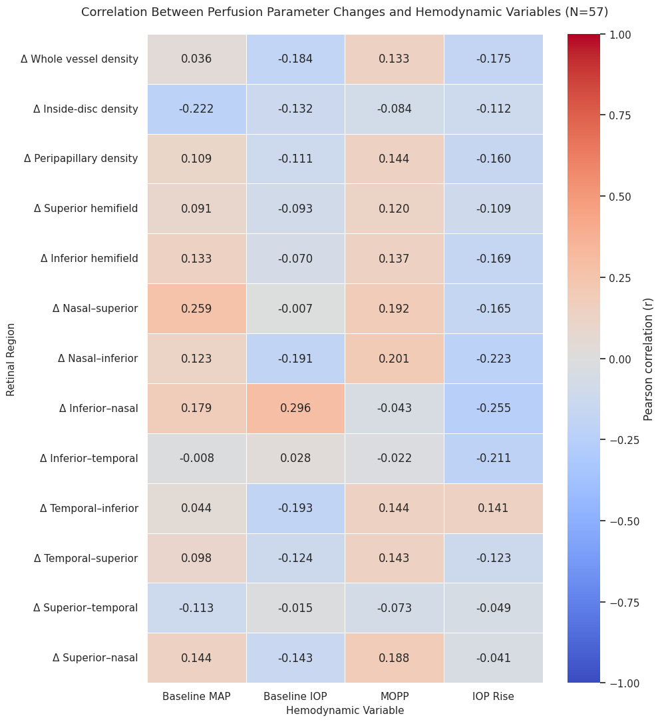
Figure 1: Heatmap correlation between baseline MAP, baseline IOP, MOPP, magnitude of IOP rise, and regional OCTA vessel density changes

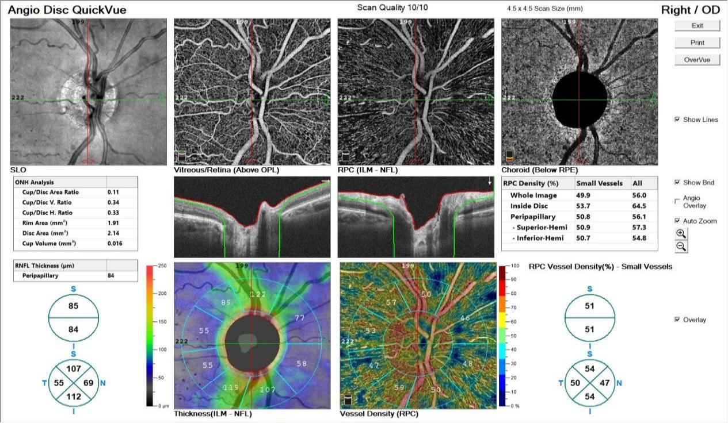

OCTA ONH of right eye before IVI

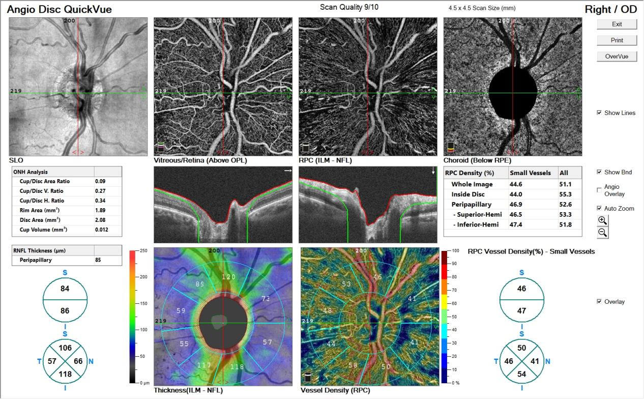

OCTA ONH of right eye after IVI

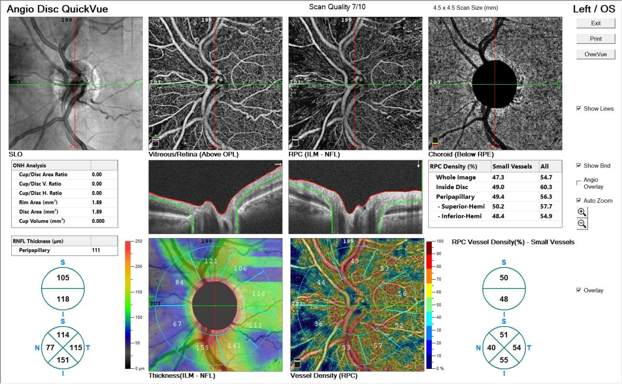

OCTA ONH of left eye before IVI

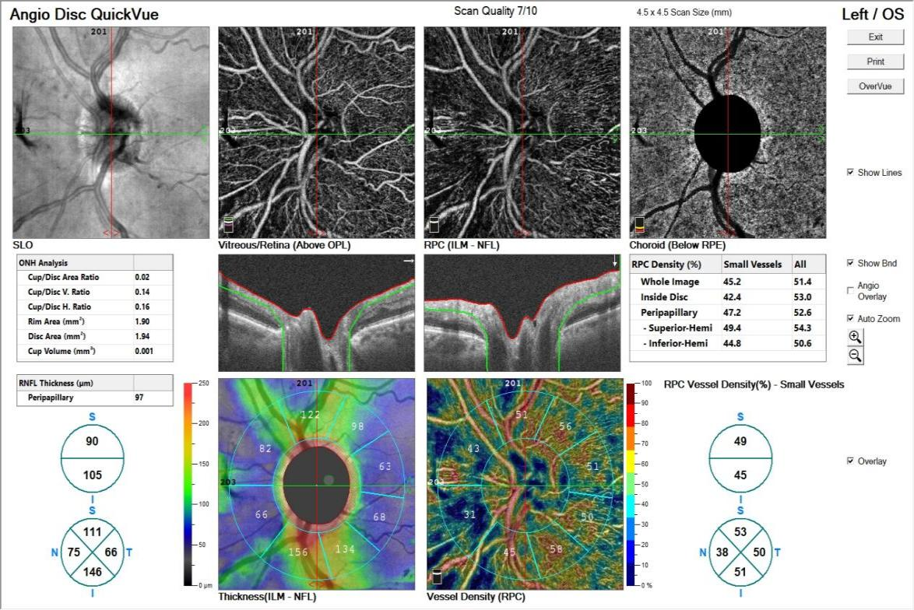

OCTA ONH of left eye after IVI.
Figure 2: A 60-year-old male with type II diabetes (20 years), hypertension, and cardiac disease (HbA1c 9%) with reduced vision in the right eye because of DME (CFT 536 µm) and received intravitreal ranibizumab. He had prior IVIs in the right eye (once) and left eye (twice). BCVA was 1/60 (right) and 6/36 (left), with IOP 17→18 mmHg (right) and 14→18 mmHg (left); anterior segments were normal. OCTA of the right eye showed a reduction in intradisc vessel density (53.7%→44%) with no significant RNFL changes; the left eye remained unchanged.

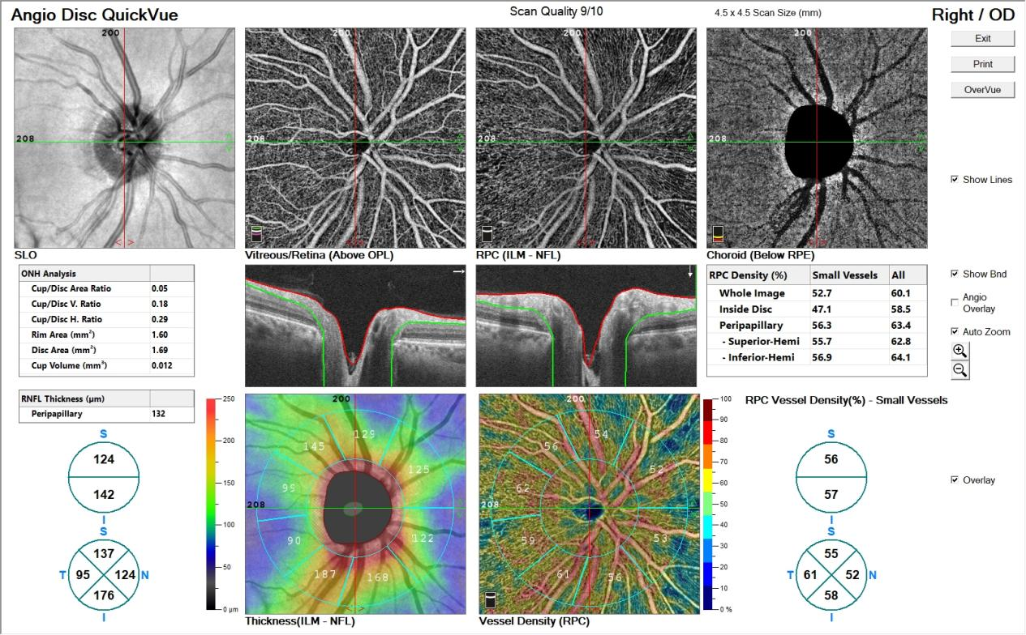

OCTA ONH of right eye before IVI

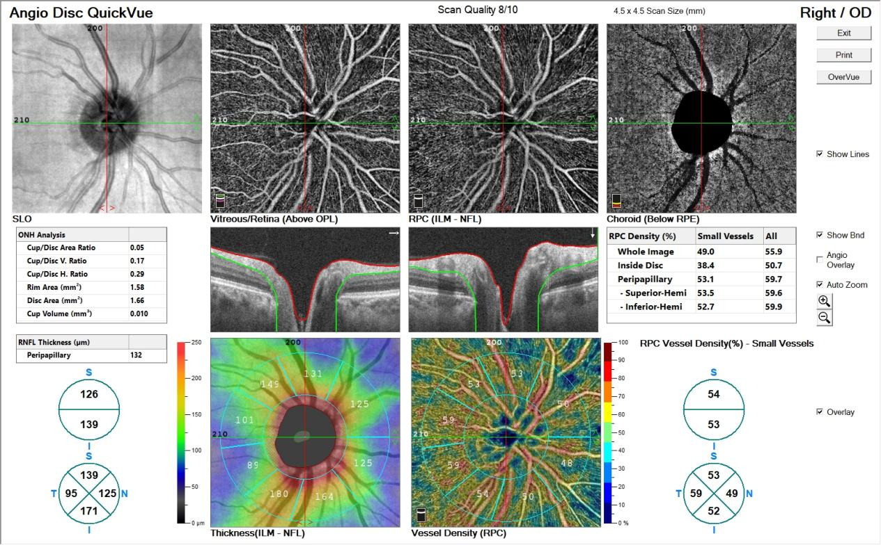

OCTA ONH of right eye after IVI

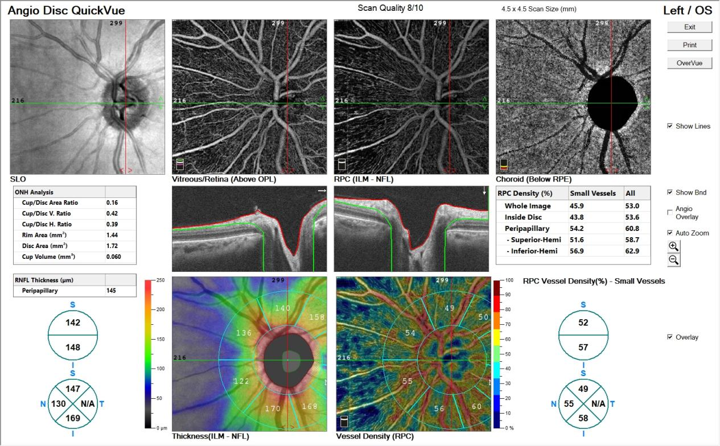

OCTA ONH of left eye before IVI

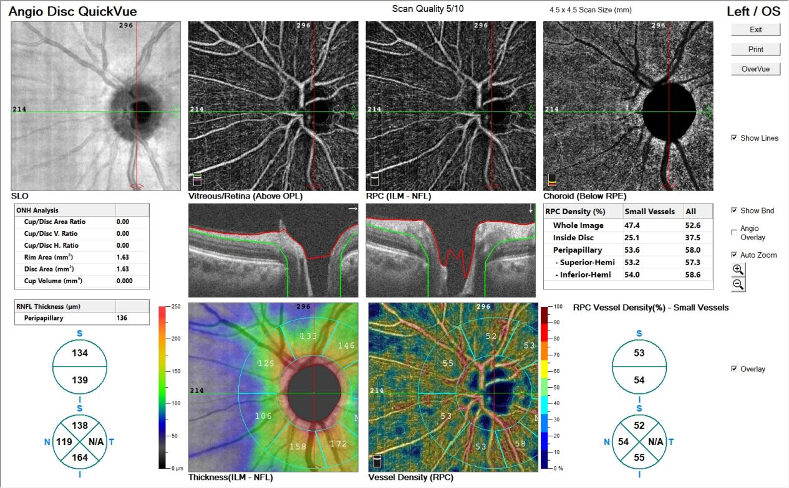

OCTA ONH of left eye after IVI
Figure 3: A 51-year-old hypertensive female with reduced vision in the left eye because of macular edema secondary to CNV (CFT 549 µm) and received intravitreal ranibizumab. She had a prior IVI in the left eye and no history of trauma. BCVA was 1/60 (left) and 6/36 (right), with IOP 16→18 mmHg (left) and 17→16 mmHg (right); anterior segments were normal. OCTA of the left injected eye showed a marked reduction in intradisc vessel density (43.8%→25.1%) and RNFL thickness globally (145→136 µm), superiorly (142→134 µm), and inferiorly (148→139 µm), while the uninjected right eye remained unchanged.

Discussion
Intravitreal anti-VEGF therapy has evolved into the cornerstone of management for various retinal vascular illnesses, like DME, BRVO, and CNV. By targeting VEGF-mediated vascular permeability and neovascularization, these agents significantly improve visual outcomes and reduce macular edema. Despite their widespread efficacy and safety, concerns remain regarding their potential effects on ocular microcirculation and ONH perfusion, particularly with repeated administration over time ^{[17]}.
Pre-injection IOP values were comparable between both eyes (P=0.930). with a significant elevation in IOP was found in injected eyes (from 16 to 18.6 mmHg on average) (P<0.001), whereas the fellow eyes showed no significant IOP change (P=0.114). The between-eye difference in post-injection IOP was not significant (P=0.391), reflecting the relatively small absolute rise.
Transient IOP elevations immediately after intravitreal injection are well documented and are thought to be primarily volume-related. In most cases, this IOP elevation is short-lived and resolves spontaneously, making the routine prophylactic use of IOP-lowering medications unnecessary ^{[18, 19]}.
Our results were in agreement with multiple reports which confirmed significant increase in IOP post IVI of anti-VEGF.
Wen et al.^{[20]} identified a significant rise in IOP immediately after the injection (P < 0.0001), which persisted at the subsequent post-injection assessment (P < 0.0001). Although there were no significant modifications in normalised flux, vessel area density, or flux immediately following injection, a significant decrease in all three parameters was demonstrates at the subsequent post-injection measurement (P = 0.03, 0.02, and 0.03, respectively). No significant alterations were demonstrated through the same duration (P = 0.47, 0.37, and 0.38, respectively) in the un-injected adjacent eye.
At baseline, ONH vessel density parameters including the whole, inside disc, peripapillary, and sectoral areas did not differ among injected and fellow eyes (all P>0.05), indicating that the two eyes were well matched before the procedure and both eyes had comparable baseline microvascular characteristics, providing a balanced starting point for assessing post-injection vascular changes and minimizing confounding factors related to inter-eye variability.
After injection, inside-disc vessel density was significantly reduced in injected eyes versus fellow eyes (P<0.001), and, within the injected group, inside-disc density showed a marked decrease, in contrast, no significant variations were found in the fellow eyes. These results indicate that the acute increase in IOP after intravitreal anti-VEGF injection may compromise ONH perfusion. Systemic factors are unlikely to be responsible for this effect, as the uninjected colleagues' pupils remained unaffected. Furthermore, no statistically significant differences were detected in whole, peripapillary, or sectoral vessel density parameters in either group (all P > 0.05), indicating that anti-VEGF administration did not produce widespread alterations in peripapillary or retinal microvascular perfusion.
In most eyes with healthy optic nerves, transient elevations in IOP are largely and rapidly counterbalanced by effective autoregulatory mechanisms, allowing the ONH to sustain comparatively stable blood flow despite fluctuations in ocular perfusion pressure.
There are numerous studies that demonstrate the impact of IVI of anti-VEGF on choriodal and retinal prefusion using various methodologies. However, our work exclusively examines the influence of IVI on ONH perfusion and employs OCTA to quantify blood flow. Fukami et al. ^{[21]} revealed that the injection led retinal vessels vasoconstriction and retinal blood flow reduction.
Several studies found no significant alterations in vessel density on OCTA following IVI, despite anatomical enhancement in edema and central subfield thickness (CST) ^{[22-24]}. These results agree with us, which also demonstrated no significant changes in overall or peripapillary vessel density following treatment. Several explanations have been proposed for this observation. First, the retinal capillaries that have sustained ischemic injury in DME may not regain perfusion even after VEGF suppression ^{[22]}. Second, the apparent stability in vessel density may reflect the displacement rather than loss of the vascular plexus caused by cystoid spaces in DME, which repositions rather than destroys retinal vessels during fluid accumulation and resolution ^{[25]}. Additionally, segmentation errors and measurement limitations in OCTA due to anatomical distortion of retinal layers in DME may contribute to the apparent absence of significant vascular change ^{[22, 23]}.
Our study results showed that at baseline before anti-VEGF injection, peripapillary RNFL thickness did not differ among injected and fellow eyes, both the overall (P=0.607) and hemispheric RNFL measurements, including the superior (P=0.485) and inferior (P=0.503) segments were comparable. After injection, cross-sectional comparisons still revealed no difference among both groups; however, within the injected eyes we observed a significant decrease in global (P=0.002) and superior hemispheric (P<0.001) RNFL thickness, with a borderline change in the inferior hemisphere (P=0.067), whereas no significant changes were detected in fellow eyes (P>0.05), indicating that the observed thinning was localized to the treated eyes and may reflect a subtle, treatment-related structural response. The magnitude of change was small (approximately 4–7 µm on average) and lies close to the reported test–retest variability of peripapillary RNFL measurements with SD-OCT.
Viggiano et al. ^{[26]}, found Immediate post-injection IOP showed a significant increase (P < 0.01). RNFL thickness demonstrated a significant reduction immediately after the injection (P = 0.001). Topographical analysis discovered significant thinning in the nasal and inferior RNFL sectors versus baseline (P = 0.046 and P = 0.001, respectively). Moreover, there was a significant negative association among global RNFL thickness and IOP changes (P = 0.031), with the nasal RNFL showing a significant negative correlation with IOP values (P = 0.046).
The biological plausibility of true structural RNFL thinning occurring within one hour following a single anti-VEGF injection is low. Therefore, these changes are more likely to represent measurement variability, transient shifts in tissue reflectivity or segmentation boundaries, or subtle changes in disc configuration related to IOP and perfusion rather than actual axonal loss.
Horsley et al. ^{[27]} determined that the thickness of the RNFL did not undergo any significant modifications as a result of long-term mangement with anti-VEGF agents. When comparing the RNFL measurements of individual anti-VEGF treatment groups, no significant differences were observed.
Shin ^{[28]} and colleagues determined that no correlation among anti-VEGF injections and RNFL thickness. Nevertheless, there was demonstration that recurrent anti-VEGF injections were correlated with loss of RNFL.
Limitations included relatively small sample size, only a single early post-injection time point (one hour) was evaluated, the cohort included different underlying retinal vascular diseases, OCTA measurements can be influenced by signal strength, motion artefacts, and segmentation errors; although scans of poor quality were excluded.

Conclusions:
A single intravitreal anti-VEGF injection leads to a modest, transient elevation in IOP and short-term reduction in intradisc vessel density, with largely preserved peripapillary perfusion. While generally safe for most patients, repeated injections in eyes with compromised optic nerves or high-risk individuals may have cumulative effects. Careful monitoring and IOP-lowering strategies should be considered in such cases.

Conflict of Interest: The authors declare no conflict of interest.

Financial Support and Sponsorship: No financial support was provided.

References:
1. Zhi Z, Cepurna WO, Johnson EC, Morrison JC, Wang RK. Impact of intraocular pressure on changes of blood flow in the retina, choroid, and optic nerve head in rats investigated by optical microangiography. Biomed Opt Express. 2012;3:2220-33.
2. Jia Y, Simonett JM, Wang J, Hua X, Liu L, Hwang TS, et al. Wide-Field OCT Angiography Investigation of the Relationship Between Radial Peripapillary Capillary Plexus Density and Nerve Fiber Layer Thickness. Invest Ophthalmol Vis Sci. 2017;58:5188-94.
3. Steinmetz JD, Bourne RR, Briant PS, Flaxman SR, Taylor HR, Jonas JB, et al. Causes of blindness and vision impairment in 2020 and trends over 30 years, and prevalence of avoidable blindness in relation to VISION 2020: the Right to Sight: an analysis for the Global Burden of Disease Study. The Lancet Global Health. 2021;9:e144-e60.
4. Sun JK, Glassman AR, Beaulieu WT, Stockdale CR, Bressler NM, Flaxel C, et al. Rationale and Application of the Protocol S Anti-Vascular Endothelial Growth Factor Algorithm for Proliferative Diabetic Retinopathy. Ophthalmology. 2019;126:87-95.
5. Gross JG, Glassman AR, Jampol LM, Inusah S, Aiello LP, Antoszyk AN, et al. Panretinal Photocoagulation vs Intravitreous Ranibizumab for Proliferative Diabetic Retinopathy: A Randomized Clinical Trial. Jama. 2015;314:2137-46.
6. Mitchell P, Bandello F, Schmidt-Erfurth U, Lang GE, Massin P, Schlingemann RO, et al. The RESTORE study: ranibizumab monotherapy or combined with laser versus laser monotherapy for diabetic macular edema. Ophthalmology. 2011;118:615-25.
7. Falavarjani KG, Nguyen QD. Adverse events and complications associated with intravitreal injection of anti-VEGF agents: a review of literature. Eye (Lond). 2013;27:787-94.
8. Demirel S, Yanik O, Batioglu F, Ozmert E. Intraocular pressure changes related to intravitreal injections of ranibizumab: analysis of pseudophakia and glaucoma subgroup. Int Ophthalmol. 2015;35:541-7.
9. Bakri SJ, Pulido JS, McCannel CA, Hodge DO, Diehl N, Hillemeier J. Immediate intraocular pressure changes following intravitreal injections of triamcinolone, pegaptanib, and bevacizumab. Eye (Lond). 2009;23:181-5.
10. Bressler SB, Almukhtar T, Bhorade A, Bressler NM, Glassman AR, Huang SS, et al. Repeated intravitreous ranibizumab injections for diabetic macular edema and the risk of sustained elevation of intraocular pressure or the need for ocular hypotensive treatment. JAMA Ophthalmol. 2015;133:589-97.
11. Bracha P, Moore NA, Ciulla TA, WuDunn D, Cantor LB. The acute and chronic effects of intravitreal anti-vascular endothelial growth factor injections on intraocular pressure: A review. Surv Ophthalmol. 2018;63:281-95.
12. Hoguet A, Chen PP, Junk AK, Mruthyunjaya P, Nouri-Mahdavi K, Radhakrishnan S, et al. The Effect of Anti-Vascular Endothelial Growth Factor Agents on Intraocular Pressure and Glaucoma: A Report by the American Academy of Ophthalmology. Ophthalmology. 2019;126:611-22.
13. Wang X, Jiang C, Ko T, Kong X, Yu X, Min W, et al. Correlation between optic disc perfusion and glaucomatous severity in patients with open-angle glaucoma: an optical coherence tomography angiography study. Graefes Arch Clin Exp Ophthalmol. 2015;253:1557-64.
14. Hwang JC, Konduru R, Zhang X, Tan O, Francis BA, Varma R, et al. Relationship among visual field, blood flow, and neural structure measurements in glaucoma. Invest Ophthalmol Vis Sci. 2012;53:3020-6.
15. Spaide RF, Fujimoto JG, Waheed NK, Sadda SR, Staurenghi G. Optical coherence tomography angiography. Prog Retin Eye Res. 2018;64:1-55.
16. Miguel AIM, Silva AB, Azevedo LF. Diagnostic performance of optical coherence tomography angiography in glaucoma: a systematic review and meta-analysis. Br J Ophthalmol. 2019;103:1677-84.
17. Hang A, Feldman S, Amin AP, Ochoa JAR, Park SS. Intravitreal Anti-Vascular Endothelial Growth Factor Therapies for Retinal Disorders. Pharmaceuticals (Basel). 2023;16.
18. Frenkel MP, Haji SA, Frenkel RE. Effect of prophylactic intraocular pressure-lowering medication on intraocular pressure spikes after intravitreal injections. Arch Ophthalmol. 2010;128:1523-7.
19. Shin HJ, Shin KC, Chung H, Kim HC. Change of retinal nerve fiber layer thickness in various retinal diseases treated with multiple intravitreal antivascular endothelial growth factor. Invest Ophthalmol Vis Sci. 2014;55:2403-11.
20. Wen JC, Chen CL, Rezaei KA, Chao JR, Vemulakonda A, Luttrell I, et al. Optic Nerve Head Perfusion Before and After Intravitreal Antivascular Growth Factor Injections Using Optical Coherence Tomography-based Microangiography. J Glaucoma. 2019;28:188-93.
21. Fukami M, Iwase T, Yamamoto K, Kaneko H, Yasuda S, Terasaki H. Changes in Retinal Microcirculation After Intravitreal Ranibizumab Injection in Eyes With Macular Edema Secondary to Branch Retinal Vein Occlusion. Invest Ophthalmol Vis Sci. 2017;58:1246-55.
22. Toto L, D'Aloisio R, Di Nicola M, Di Martino G, Di Staso S, Ciancaglini M, et al. Qualitative and Quantitative Assessment of Vascular Changes in Diabetic Macular Edema after Dexamethasone Implant Using Optical Coherence Tomography Angiography. Int J Mol Sci. 2017;18.
23. Ghasemi Falavarjani K, Iafe NA, Hubschman JP, Tsui I, Sadda SR, Sarraf D. Optical Coherence Tomography Angiography Analysis of the Foveal Avascular Zone and Macular Vessel Density After Anti-VEGF Therapy in Eyes With Diabetic Macular Edema and Retinal Vein Occlusion. Invest Ophthalmol Vis Sci. 2017;58:30-4.
24. Sorour OA, Sabrosa AS, Yasin Alibhai A, Arya M, Ishibazawa A, Witkin AJ, et al. Optical coherence tomography angiography analysis of macular vessel density before and after anti-VEGF therapy in eyes with diabetic retinopathy. Int Ophthalmol. 2019;39:2361-71.
25. Tarassoly K, Miraftabi A, Soltan Sanjari M, Parvaresh MM. THE RELATIONSHIP BETWEEN FOVEAL AVASCULAR ZONE AREA, VESSEL DENSITY, AND CYSTOID CHANGES IN DIABETIC RETINOPATHY: AN OPTICAL COHERENCE TOMOGRAPHY ANGIOGRAPHY STUDY. Retina. 2018;38:1613-9.
26. Viggiano P, Buonamassa R, Grassi MO, Boscia G, Borrelli E, Landini L, et al. Immediate effect of anti-VEGF injections on optic nerve head: Correlation between intraocular pressure and anatomical peripapillary changes. Eur J Ophthalmol. 2024;34:1174-82.
27. Horsley MB, Mandava N, Maycotte MA, Kahook MY. Retinal nerve fiber layer thickness in patients receiving chronic anti-vascular endothelial growth factor therapy. Am J Ophthalmol. 2010;150:558-61.e1.
28. Shin HJ, Kim SN, Chung H, Kim TE, Kim HC. Intravitreal Anti-Vascular Endothelial Growth Factor Therapy and Retinal Nerve Fiber Layer Loss in Eyes With Age-Related Macular Degeneration: A Meta-Analysis. Invest Ophthalmol Vis Sci. 2016;57:1798-806.

